DS200 API Description

V 1.0.0

Writing purpose
This document is used to describe the API usage of Dinghe Cloud Speaker SDK, enabling programmers to quickly carry out secondary development.。

Platform
The API described in this document is applicable to the Dinghe Cloud Speaker Mobile EC600X platform.

API

Streaming API
    - ql_set_volume
 | void ql_set_volume(AUDIOHAL_SPK_LEVEL_T vol);
Func | Set system volume
Param | vol: The volume size to be set, refer to the enumeration AUDIOHAL_SPK_LEVEL_T
Return | VOID

    - ql_get_volume
 | int ql_get_volume(void);
Func | Get the current system volume
Param | VOID
Return | Current volume level
    - tts_play_immediately
 | int tts_play_immediately(const char* buf,int len, tts_text_type type);
Func | Audio broadcast message release function, searches for files through strings and plays them (high priority, plays immediately, queue number is one, only supports storing one broadcast message)
Param | buf Index of the broadcasted string  len string length  type Broadcast type (using FILE_TEXT, supports single file)
Return | 0 succeed  1 error
    - tts_play_set
 | int tts_play_set(const char* buf,int len, tts_text_type tts_type);
Func | Audio broadcast message release function, searches for files through strings and plays them (low priority, queue size of 50, only supports storing 50 broadcast messages)  PS: Broadcast multiple file combinations, such as payment message broadcast, type AMTtEXT. The function called is mqtt_play_analy, as shown in the table below
Param | buf Index of the broadcasted string  len buf length  type Broadcast type (using FILE_TEXT, supports single file)
Return | 0 succeed  1 error
    - mqtt_play_analy
 | int mqtt_play_analy(struct tts_buff_msg * reviceMsg);
Func | The fixed format for parsing the amount message broadcast is (payment institution+amount+unit)
Param | reviceMsg The structure of the incoming voice message, the specific content depends on the definition of the structure tts_buff_msg
Return | 0 succeed  1 error
    - q tts_play_local_file
 | tts_play_local_file(file_root_path);
Func | Audio file playback, playing audio files from the file system in WAV, MP3 formats
Param | file_root_path file name
Return | 0 succeed  1 error
    - ql_mp3_file_play
 | int ql_mp3_file_play(char *file_name);
Func | MP3 file playback
Param | file_name file path
Return | 0 succeed  other error
    - ql_mp3_file_play2
 | int ql_mp3_file_play2(char *data, unsigned int size);
Func | MP3 streaming playback
Param | data Stream data pointer  size length
Return | 0 succeed  other error
    - ql_mp3_file_stop
 | void ql_mp3_file_stop(void);
Func | MP3 stream playback stopped
Param | VOID
Return | VOID
    - ql_wav_file_play
 | int ql_wav_file_play (char *file_name);
Func | MAV file playback
Param | file_name file path
Return | 0 succeed  other error
    - ql_wav_file_play2
 | int ql_wav_file_play2(char *data, unsigned int size);
Func | WAV streaming playback
Param | data Stream data pointer  size length
Return | 0 succeed  other error
    - ql_wav_file_stop
 | void ql_wav_file_stop(void);
Func | WAV stream playback has stopped
Param | VOID
Return | VOID
    - ql_amr_file_play
 | int ql_amr_file_play(char *file_name);
Func | AMR file playback
Param | file_name file path
Return | 0 succeed  other error
    - ql_amr_file_play2
 | int ql_amr_file_play2(char *data, unsigned int size);
Func | AMR streaming playback
Param | data data pointer  size data length
Return | 0 succeed  other error
    - ql_amr_file_stop
 | void ql_amr_file_stop(void);
Func | AMR stream playback stopped
Param | VOID
Return | VOID

设备信息获取
    - ql_dev_get_cpu_uid
 | void ql_dev_get_cpu_uid(unsigned long long * uid_ret);
Func | Get cpu_uid
Param | uid_ret: Used for saving device's cpu_uid
Return | VOID
    - sysparam_get
 | struct sysparam *sysparam_get(void);
Func | Retrieve the current system parameters, which can be defined in systemparam. h. The storage nature is to shut down without loss
Param | VOID
Return | sysparam Pointer to device information  NULL error
    - ql_dev_get_imei
 | QL_DEV_ERROR_CODE ql_dev_get_imei(char *imei,unsigned int imei_len);
Func | Obtain the IMEI of the device.
Param | imei：IMSI of the device, string  imei_len：imei length
Return | QL_DEV_SUCCESS succeed  QL_DEV_GENERIC_FAILURE error
    - ql_dev_get_mac
 | int ql_dev_get_mac(unsigned char *mac_val,unsigned int len);
Func | Obtain the MAC number of the customer's device (17 bytes)
Param | V mac_val：Store MAC buffer, with at least 17 bytes of incoming buffer.  version_len：MAC number length; For 17 bytes
Return | 0 succeed  other error
    - Module_Net_State
 | int Module_Net_State(void);
Func | Get 4G network status
Param | VOID
Return | 0: NET DISCON  1:NET CON
    - ql_sim_get_card_statu
 | QL_SIM_ERROR_CODE ql_sim_get_card_status(int *card_status);
Func | Get SIM card status information immediately
Param | card_status：Return SIM card LEI type information, see QL_SIM-STRUS
Return | QL_SIM_SUCCESS succeed  QL_SIM_GENERIC_FAILURE error
    - ql_nw_get_signal_strength
 | QL_NW_ERROR_CODE ql_nw_get_signal_strength(QL_NW_SIGNAL_STRENGTH_INFO_T *pt_info);
Func | Obtain detailed signal strength
Param | pt_info Return detailed signal strength
Return | 0 succeed  other error
    - battery_read_percent
 | uint8_t battery_read_percent(void);
Func | Obtain battery level
Param | VOID
Return | 0 to 100 Corresponding percentage  0： 0%  100：100%
    - ql_rtos_get_free_heap_size
 | int ql_rtos_get_free_heap_size();
Func | Get the user's available memory size
Param | VOID
Return | memory size

Device Reboot
    - ql_power_reset
 | void ql_power_reset();
Func | Restart module (will wait for RF to be turned off before restarting)
Param | VOID
Return | VOID

HTTP
    - Ext_Wifi_AppOta
 | int Ext_Wifi_AppOta(char * url);
Func | OTA package download and verification
Param | VOID
Return | 0：succeed other：error
    - Gprs_HTTPC_PostB
 | int Gprs_HTTPC_PostB(HTTPParam *httpinfo, const char * const * HeadAdd,CHAR *Buffer,INT32 bufSize, unsigned int *recvSize);
Func | HTTP post request sending and server response receiving
Param | httpinfo The information sent includes the URL and the content being sent  headAdd Head information  Buffer Pointer for receiving data  bufSize Maximum length received  recvSize The actual length returned
Return | 0 succeed  other error

LED
    - LedModeSet
 | static void LedModeSet(int LedSel,LedStatSet Mode);
Func | LED light mode setting
Param | LedSel color set BLUE_LED_SET  GREEN_LED_SET  RED_LED_SET  Mode mode set Blink Alternating flashes  FlashFast flash mob  FlashSlow slow flash  AlwaysOn always on  AlwaysOff always off
Return | VOID
    - setRedLedOnOff
 | void setRedLedOnOff(uint8_t on);
Func | Red light display control
Param | 1 on  0 off
Return | VOID
    - setBlueLedOnOff
 | void setBlueLedOnOff(uint8_t on);
Func | Blue light display control
Param | 1 on  0 off
Return | VOID
    - setGreenLedOnOff
 | void setGreenLedOnOff(uint8_t on);
Func | Green light display control
Param | 1 on  0 off
Return | VOID

MQTT
    - tcp_mqtt_client
 | int tcp_mqtt_client(Client* client);
Func | MQTT client settings (TCP)
Param | client client
Return | 0 succeed  other error
    - ssl_mqtt_client
 | I int ssl_mqtt_client(Client* client, const char *ca_cert, uint32_t ca_length);
Func | MQTT client settings (tls)
Param | client client  ca_cert cert  ca_length cert length
Return | 0 succeed  other error
    - MQTTConnect
 | int MQTTConnect(Client* c, MQTTPacket_connectData* options)；
Func | MQTT connection
Param | client Client
Return | 0 succeed  other error
    - MQTTSubscribe
 | int MQTTSubscribe(Client* c, const char* topicFilter, enum QoS qos, messageHandler messageHandler);
Func | MQTT subscription
Param | c client  topic Subscription topics  qos Quality of publication  messageHandler The callback function interface for receiving messages
Return | 0 succeed  other error
    - MQTTPublish
 | int MQTTPublish(Client* c, const char* topicName, MQTTMessage* message);
Func | MQTT publish
Param | c client  topic Subscription topics  message The content of the published message
Return | 0 succeed  other error

File system API
Only list some commonly used ones, please refer to ql_fs. h for others
    - 3.37 ql_fopen
 | QFILE * ql_fopen(const char *fname, const char *mode);
Func | Open files in the file system
Param | fname file path  mode open mode
Return | File stream
    - 3.38 ql_fwrite
 | int ql_fwrite(void * buffer, size_t size, size_t num, QFILE * fp);
Func | File write operation
Param | buff Written data  size buff length  num File write format size  fp file stream
Return | The actual length written
    - 3.39 ql_fclose
 | int ql_fclose(QFILE * fp);
Func | Close the file
Param | fp file stream
Return | LFS_ERR_OK: no error.  other: error
    - 3.40 ql_fsize
 | int ql_fsize(QFILE *fp);
Func | Get file length
Param | fp file stream
Return | File length
    - 3.41 ql_fread
 | int ql_fread(void * buffer, size_t size, size_t num, QFILE * fp);
Func | Read file
Param | buff Read out the content  size Read out the content  num File write format size  fp file stream
Return | The actual length read out
    - 3.42 ql_remove
 | int ql_remove(const char *fname);
Func | Remove file
Param | fname file path
Return | LFS_ERR_OK: no error.  other: error
    - 3.43 ql_copy
 | int ql_copy(const char *oldpath, const char *newpath);
Func | Copy file
Param | oldpath old file path  newpath new file path
Return | LFS_ERR_OK: no error.  other: error
    - 3.44 ql_access
 | int ql_access(const char *path, u32 mode);
Func | Check if the file exists
Param | fname file path  mode access pattern
Return | LFS_ERR_OK: no error.  other: error

Network Multimedia API
    - 3.45 tts_play_set_user_def
 | int tts_play_set_user_def(char const * usermsg,int BreakEna,int playnow );
Func | Network streaming media playback (only supports MP3), this feature only supports playing MP3 files with sampling rates below 44Khz in wifi mode, and supports full sampling rates in 4G mode
Param | usermsg: The URL that needs to be played  BreakEna：Interrupt flag (reserved interface, not implemented)  Playnow：Broadcast priority (1: high 0: low)
Return | 0：success 1：fail

    - 3.46 voice_stop
 | int voice_stop(void)
Func | Stop streaming media playback
Param
Return | 0：success -1：fail
    - 3.47 voice_state
 | int voice_state(void)；
Func | Streaming media playback status
Param
Return | 0：No playback 1：playing

Button customization instructions
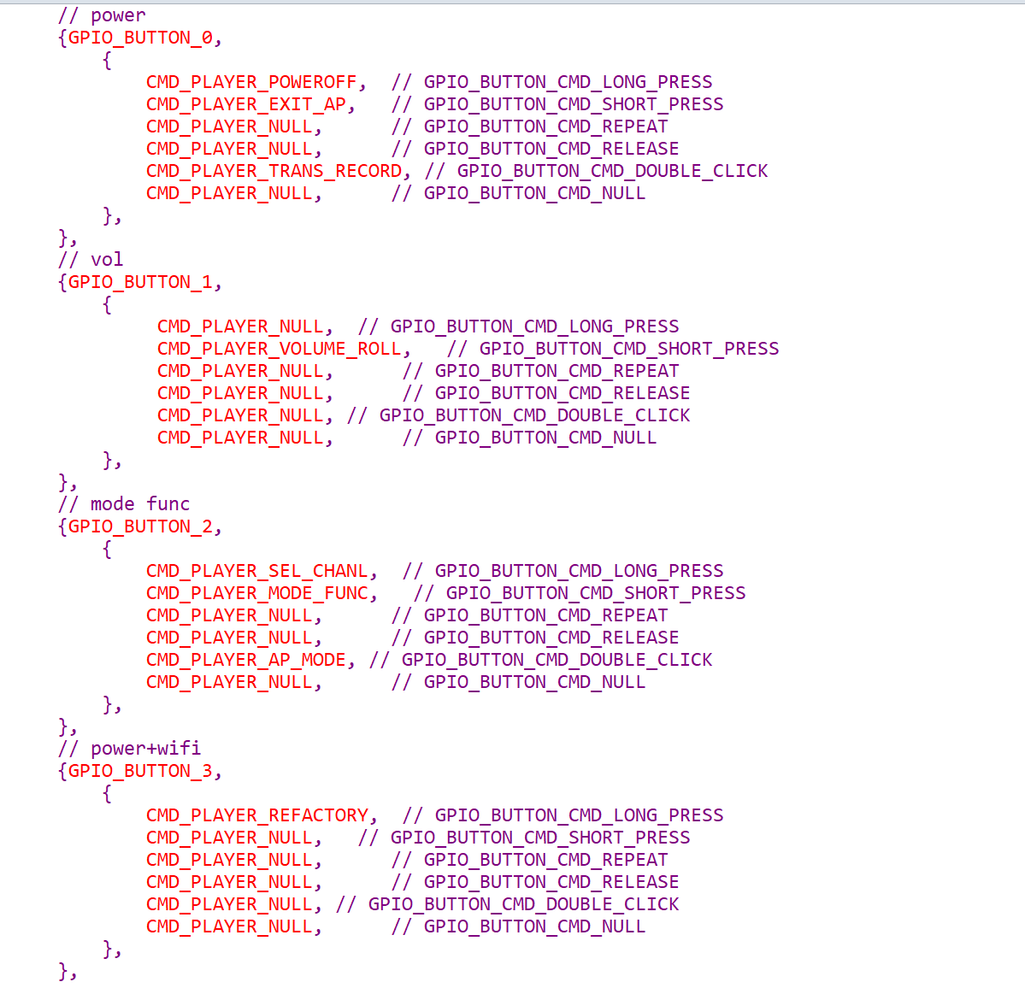

The button customization function is defined by macros GPIO_BUTTON_USER_DEF (button.c)。
Replace, add, delete key events, and modify them in the ButtonConfig array of key definitions.
The actual key processing is done in the button_queue_ event function, where events can be modified and called functions can be added.

